
HEALTH, SAFETY & ENVIRONMENT MANAGEMENT SYSTEM
DAN Construction Safety Manual (DCSM)
Hand Tools and Power Tools

Document Control
Document No. | 01-000001-000000-DAN-HSE-PRC-000040 | Revision | R01
Issue Date | June 2026 | Classification | Controlled — Internal
Document Owner | HSE Department | Page Format | US Letter

Table of Contents

1. Purpose
2. Scope
3. References
4. Definitions
5. Deliverables
6. General Precautions
7. Hand Tools
8. Electric Power Tools
9. Extension Cords and Portable Lights
10. Pneumatic and Fuel-Powered Tools
11. Hydraulic Jacks
12. Abrasive Wheels and Grinders
13. Woodworking Tools and Saws
14. Powder-Actuated (Explosive-Charge) Tools
15. Training
16. Documentation / Related Documents
Figures and Illustrations
Revision History

1. Purpose
This document provides the minimum DAN safety requirements for the selection, use and care of hand tools and power tools — both portable and fixed — to ensure the safety of personnel using them.

2. Scope
This document applies to all hand tools, electric, pneumatic, fuel-powered, hydraulic and powder-actuated tools used on DAN projects, including their guarding, inspection, storage and operator training.
Note: This document does not apply to concrete vibrators/breakers, powered tampers, jackhammers, rock drills, garden/household/personal-care appliances, medical/dental equipment or fixed machinery (see the Machine Guarding chapter).

3. References
- 29 CFR 1910 Subpart O & P; 29 CFR 1926 Subpart I — Tools, Hand and Power
- ANSI A10.3 — Powder-Actuated Fastening Systems; ANSI B7.1 — Abrasive Wheels; ANSI B15.1
- EM 385-1-1, Section 11 — Electrical: Tools; NFPA 70 (NEC)
- DCSM — Electrical Safety; DCSM — Machine Guarding; DCSM — Personal Protective Equipment

4. Definitions
Term | Definition
Powder-Actuated Tool | A tool that uses an explosive charge to drive a fastener into a base material.
Constant-Pressure Control | A switch that shuts off power when finger pressure is released ("dead-man" control).
Job-Made Extension Cord | An extension cord fabricated on-site by a certified electrician from approved flexible cable.
Ring Test | Tapping an abrasive wheel to listen for the clear ring that indicates it is free of cracks.

5. Deliverables
- Hand Tools & Power Tools Procedures
- Hand Tools & Power Tools Register
- Tool inspection records / "DEFECTIVE" tagging

6. General Precautions
- All tools shall be maintained in a safe condition and inspected before work; defective tools shall be removed from service and tagged "DEFECTIVE" or "DO NOT USE".
- AHAs shall identify the tools required for each task and the specific hazards; appropriate PPE shall be used against dust, fumes, mists, vapours, gases, falling objects and flying/abrasive/splashing materials.
- Near energised electrical circuits, do not use hammers with metal handles, screwdrivers, knives with metal continuing through the handle, or metallic measuring tapes — and do not rely on hand-tool insulation to protect against shock.
- Machines designed for fixed locations shall be anchored to prevent movement; points of operation and moving/rotating parts shall be guarded, and blade peripheries guarded with openings no larger than 1/2 in.
- Only cutting tools shall be used to cut metal strapping or banding.

7. Hand Tools
- Sharp tools are safe tools — sharpen regularly and inspect for defects; do not use wrenches with sprung jaws where slippage could occur.
- Use holders or tongs to grip chisels, drills, punches, ground rods and pipes while they are struck — never hold them by hand; do not extend a wrench handle with a pipe ("cheater bar") unless designed for it.
- Keep impact tools (drift pins, wedges, chisels) free of mushroomed heads; replace splintered or cracked wooden handles (kept tight) and never tape or lash a damaged handle.
- Specific tools: screwdriver tips shall fit the screw slot and handles be insulated for electrical work; pliers shall not be used as wrenches; hammer handles shall be smooth timber, bonded fibreglass or integral steel; chisel cutting edges shall be kept sharp; hacksaw teeth shall point forward (away from the body); hand-saw blades shall be sheathed when not in use; correct-size spanners/wrenches shall be used and "cheater bars" are prohibited; pipe-wrench teeth shall be kept clean and sharp and the wrench never struck with or used as a hammer; hand-excavation tools (picks/shovels) shall be free of cracks, splinters and blunt or jagged blades, with shafts firmly attached.
- Storage: never store or carry tools with uncovered sharp edges (cover with leather or durable material); keep cutting tools in guards or compartments; do not carry sharp tools in pockets or leave tools as trip hazards; cover open gratings (or barricade) when working above to prevent dropped tools.

8. Electric Power Tools
- Electric power tool use shall conform to the Electrical Safety chapter and the project assured-grounding plan (qualified persons, identification, grounding, GFCIs, testing/colour-coding, visual inspection).
- Portable electric tools and appliances, except double-insulated tools, shall be grounded; hand-held tools shall have a manually held "on" switch; damaged tools shall be marked and taken out of service immediately, and cords shall not be used for hoisting/lowering tools.
- Portable electric power tools shall be UL-listed or FM-approved (or equivalent), bear the appropriate trademark, and be double-insulated or grounded with a three-prong plug.
- Hand-held circular saws with blade diameter greater than 2 in (5 cm), all chainsaws, and percussion tools without positive accessory-holding means shall have a constant-pressure switch that shuts off power when released; gasoline chainsaws shall have a constant-pressure throttle control.

9. Extension Cords and Portable Lights
- Extension cords shall be as short as possible; three-wire conductor type with correct grounding pins; meet NFPA 70 grounding, polarity and over-current requirements; be rated for outdoor use ("W" jacket); be #12 AWG minimum below 100 ft (30 m) and #10 AWG minimum at 100 ft or longer; not be used as permanent wiring; and be UL-listed/FM-approved if factory-made.
- Job-made extension cords shall be fabricated by a certified electrician from junior-hard or hard-service flexible cable (NFPA 70 Article 400), marked along their length, and fitted with receptacle boxes/plugs labelled NEMA Type 4/4X or IEC IP 55.
- Portable lights shall have insulated handles and substantial guards, be UL-listed/FM-approved and grounded if AC, be inspected before issue, be repaired or replaced if defective, and not be placed where their heat could ignite combustibles; flashlights used in confined-space classified areas shall be explosion-proof.

10. Pneumatic and Fuel-Powered Tools
- Air hoses and connections shall be rated for the pressure and service, and the manufacturer's safe operating pressure shall not be exceeded; tools shall be secured to hoses by positive means (pin or wire) unless a ball-check device is provided at the source; hoses over 1/2 in (1.27 cm) ID shall have a safety device at the supply to reduce pressure on hose failure.
- Pneumatic impact tools shall have safety clips/retainers; nail guns operating at 100 psi shall eject fasteners only when the muzzle contacts the work and a separate trigger is activated simultaneously; twist-lock fittings shall be secured with couplers and safety wires/pins, and screw-type ("Jubilee") clamps shall not be used.
- Compressed air used for cleaning shall be less than 30 psi, with chip guarding and PPE, and shall never be directed at any person; systems at or above 30 psig nozzle pressure shall have a relief device limiting dead-ended pressure below 30 psig.
- Fuel-powered tools shall be refuelled/serviced only when stopped; fuels handled per the Hazardous Materials chapter; indoor use shall control carbon-monoxide build-up via ventilation/exhaust, with respirators used only where engineering controls cannot reduce concentrations to safe levels.

11. Hydraulic Jacks
- Jacks shall be permanently and legibly marked with their rated load capacity, and the load shall be less than that capacity; jacks shall be placed on level, solid support with the load centred, and the load immediately blocked/secured once raised.
- Jacks shall not be used where there is a hydraulic-oil leak; the release mechanism shall be marked and protected from accidental operation; jacks shall be lubricated regularly, thoroughly inspected at least every 6 months (and after any abnormal load/shock), and damaged jacks removed from service immediately.

12. Abrasive Wheels and Grinders
- Wear safety glasses and a face shield when grinding; inspect and ring-test wheels before mounting and turn the wheel by hand before applying power; do not exceed the wheel's marked maximum speed or use it on soft metals unless designed for them.
- Bench/floor grinders shall have substantial guards (top half of the wheel enclosed; maximum angular exposure 180°, or 90° on fixed grinders increasing to 125° for below-spindle work but never more than 65° above the spindle), work rests adjusted to no more than 1/8 in (3 mm) from the wheel, and tongue guards within 1/4 in (6 mm).
- Wheels shall slide onto the spindle without forcing and the nut not over-tightened; the sides of a wheel shall not be used as a grinding surface; grooved or damaged wheels shall be replaced immediately; flanges shall be of equal diameter (no washers in place of flanges) and at least one-third of the wheel diameter.

13. Woodworking Tools and Saws
- Fixed woodworking tools shall have a disconnect lockable only in the OPEN position; do not exceed marked blade speeds; provide anti-restart protection so machines do not restart automatically after a power failure (except hand-held portable tools).
- Portable circular saws (blade greater than 2 in / 5 cm) shall have guards above and below the base plate, with the lower guard automatically returning to the covering position when withdrawn; belt sanders shall be guarded at each nip point.
- Fixed table saws shall be permanently wired to a lockable emergency disconnect with start/stop at the operator, have blade guards covering the saw at all times, anti-kickback devices and a riving knife for ripping, guarding of parts under the table, and push sticks used during the last 12 in (30 cm) of any cut.
- Radial, chop/mitre saws, portable saws and chainsaws shall be guarded and operated per their specific requirements; chainsaw operators shall wear footwear, chaps, gloves and eye/hearing/head protection, maintain a firm two-handed grip, and never cut above shoulder height (kickback hazard).

14. Powder-Actuated (Explosive-Charge) Tools
- Powder-actuated tools shall be operated in strict accordance with the manufacturer's instructions and ANSI A10.3, by manufacturer-trained, qualified operators only; operators and assistants shall wear safety goggles and hearing protection (plus a face shield where a face hazard exists), and personnel in the area shall be notified, with warning signs/barriers where used extensively.
- Only state/agency-approved tools shall be used; before each use the operator verifies safety devices, cleanliness, free movement and a clear barrel; defective tools shall be removed from service and tagged "DEFECTIVE – DO NOT USE".
- Low-velocity piston tools shall be used wherever possible; tools shall not be loaded until immediately before use (unload if work is interrupted); never point a tool at any person; keep hands clear of the muzzle; hold the tool firmly and perpendicular to the surface; and start with the lightest powder load, increasing only as needed.
- Only fasteners designed for powder-actuated tools shall be used, after a centre-punch test of the base material; do not fire into hard/brittle materials (cast iron, glazed tile, hardened steel, glass block, face brick), into thin/soft materials without backing, into spalled areas, or closer than 3 in (7.62 cm) to a masonry edge or 1/2 in to a steel edge; on a misfire, hold the tool to the surface for at least 30 seconds before following the manufacturer's procedure.
- Tools and powder loads shall be kept in a dry, locked metal container painted red with white letters, labelled "Powder-Actuated Tool" and accessible only to authorised personnel, with an instruction manual, load chart, repair/cleaning tools and inspection log inside; loads of different levels shall be stored separately and never discarded in trash.

15. Training
The Contractor shall train personnel in proper tool selection, use, guarding and maintenance; the Site Safety Representative arranges training at initial assignment, and Supervisors identify additional needs during 2-week look-ahead planning. Powder-actuated-tool operators shall be trained and certified by the manufacturer or an authorised instructor (holding a valid Authorized Instructor's Card) and issued a Qualified Operator's Card only after passing training. Retraining is provided on a change of assignment, tool, equipment or process presenting a new hazard, or where deviations or knowledge gaps are identified.

16. Documentation / Related Documents
Every tool shall carry its operator's instruction manual in its case; the Issuing Supervisor maintains a current list of certified operators, authorised persons and quantities of powder-actuated tools. The Records Custodian documents all tool training and retraining; powder-actuated-tool training records are kept in individual files. Records are maintained on-site for the duration of the project and archived at project close.
- DCSM — Electrical Safety
- DCSM — Machine Guarding
- DCSM — Personal Protective Equipment
- DCSM — Hazard Communication

Figures and Illustrations

Figure 40-1 Approved Tools Trademarks
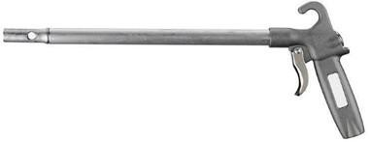
Figure 40-2 Spray Gun
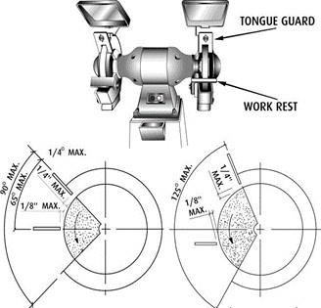
Figure 40-3 Grinder Guard Example 1
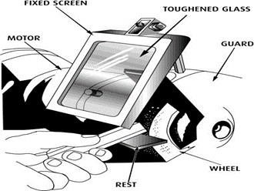
Figure 40-4 Grinder Guard Example 2
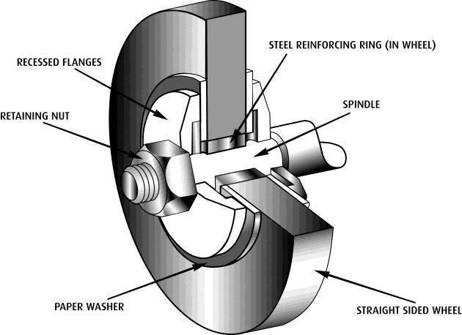
Figure 40-6 Ring Test
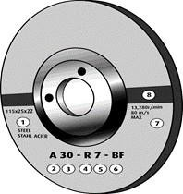
Figure 40-7 Grinding Wheel Markings
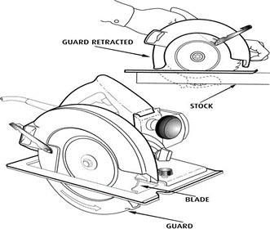
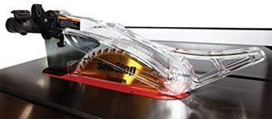
Figure 40-9 Hood Guard
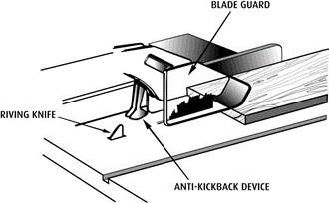
Figure 40-10 Blade Guard

Revision History
Rev. | Date | Description of Change | Approved By
R00 | June 2026 | Initial issue. Restructured to the DAN integrated HSSE management-system template and re-branded in accordance with the DAN Brand Book. | Project Director
R01 | June 2026 | Re-coded to the updated DAN document-numbering convention (01-000001-000000-DAN-{discipline}-{type}-{seq}). | Project Director

